**Q1: Calculate the time for each process, define the priority?**

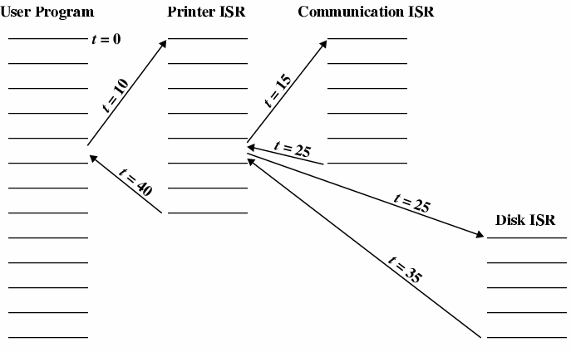

**1**  **2** **3**

**5**

**6**

**4**

**The solution :**

* user program : T = 10 S
* Printer ISR : T = 5+5= 10 S
* Communication ISR : T =10 S
* Disk ISR : T =10 S

**Priority:**

The numbers on the figure.

**الاسم :اسراء عبدالفتاح محمود رزق**

**سكشن :2**